Question 1 (30 marks)

You have been hired as part of a team to develop the LISTENX Application. LISTENX is an online music platform where customers can listen to their favourite music artist.

LISTENX should manage customers and the various music they listen to as well as recommend songs based on a customer’s music library. Each customer has a mandatory unique identity, a first name, last name, and date of birth. On LISTENX, a customer requires a music library, which consists of an identifier and a name, to listen to any music. The music library can be made up of more than one playlist. A playlist is characterised by its identifier and a name. A customer can now add songs to any playlist. LISTENX manages songs in albums which is made up of an identifier and a name. An album falls under a music genre such as RnB, Gqom, etc., and can contain more than one song. Each song has a track number, title and track time in minutes.

To speed up the development, the project has been divided into three layers: The Presentation layer, the Service layer and the data storage layer called the Repository. The Presentation layer have been given to other team members.

Using the scenario described in the problem statement, attempt the following questions:

1a. Design a domain model represented as a class diagram for the scenario above showing the various class names, attributes and UML relationships between the classes.
(20)

1b. Assume you are the team lead. Describe the process of how to set up, coordinate, and control the project, using a version control system, to manage the work done by the rest of the team efficiently. (10)

Question 2 (10 marks)

Consider the following code snippet:

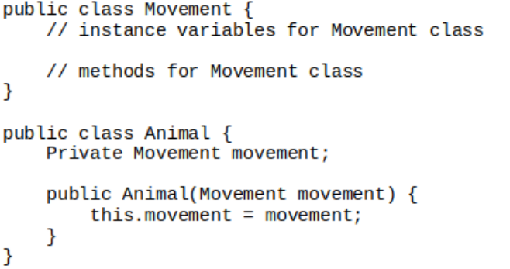

Answer the following questions:

2a. Identify the design principle violated in the code snippet above. (2)

2b. Describe and justify a fundamental OOP principle that solves the design principle violated in the code snippet above. (5)

2c. Provide the UML class diagram for a solution following your description in (b) above. (3)

Question 3 (10 marks)

Consider the following code snippet:

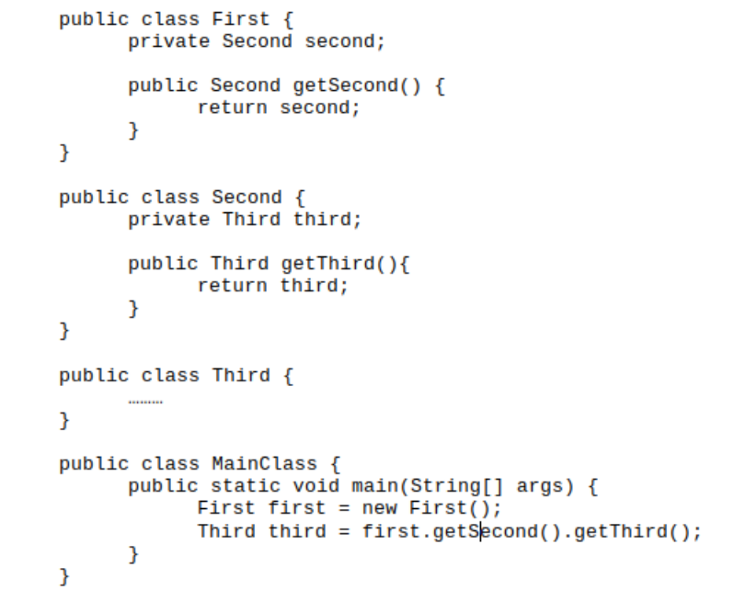

Using code snippet:

3a. Identify the design principle violated by in the code snippet. (2)

3b. Describe the design pattern that solves the design principle violated in the code snippet. (5)

3c. Provide the UML class diagram of the design pattern described in (b) above. (3)

Question 4 (2 marks)

In choosing how to model server-side components in a system design as layers or tiers, what best describes the relationship between the different tiers or layers?
 | a. | Inheritance
 | b. | Separation of concerns
 | c. | Common re-use principle
 | d. | Scalability

Question 5 (2 marks)

Compact Computers is a small computer assembly company. Their online application allows customers to pick and choose accessories to build their own PCs.

The accessories are:
i.Processor -800Mhz, 1Ghz, 1.2Ghz
ii. HDD - 40 GB, 60 GB, 80 GB
iii. Memory -128 MB, 256 MB, 512 MB

If a computer can have exactly 1 processor, 1 HDD and 1 memory stick, identify and describe the design pattern that would be best suited here?
 | a. | Factory Method
 | b. | Builder
 | c. | Prototype
 | d. | Abstract Factory
 | e. | Singleton

Question 6 (2 marks)

You have had enough with all the UML tools on the market as none do exactly what you want them to. So you've decided to design your own. However when designing it you realize that certain parts will be really complicated for example you have a Diagram object that is made up of lots of other objects. This diagram object can be used for a variety of different diagrams including class and sequence diagrams. When you create it you only want to specify its type and content. What pattern should you use?
 | a. | Abstract Factory
 | b. | Factory Method
 | c. | Builder
 | d. | Decorator

Question 7 (2 marks)

You are creating a web application for an online product ordering system. You have decided to use connection pooling to reduce load on the databases. Since you have many databases, you want to create one pool instance of the ConnectionPool class for each database. Depending on what is requested, you may have to connect to a variable number of databases. What pattern should you use?
 | a. | Factory Method
 | b. | Builder
 | c. | Prototype
 | d. | Abstract Factory
 | e. | Singleton

Question 8 (2 marks)

One of the core software design principles states that Software entities (classes, modules, functions, etc.) should be open for extension but closed for modification. This principle is
called OCP. The two Design Patterns that enforce OCP are __________ and __________.
(1 mark awarded for each correct answer)

Total Marks: 60
The End!

